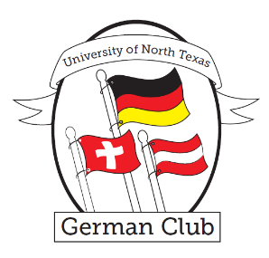University of North Texas

German Club

# 

# About the Club

The German Club is a student organization that helps immerse students in the German culture and language. Each semester we provide opportunities for students to meet and mingle with their peers and the German faculty and practice their German.

See OrgSync for more info.

# 

Contact Emily Mills, the German Club president, for questions.

Email: EmilyMills2@my.unt.edu

# Upcoming Events

**Stammtisch**

February 10th – Abby Inn in Denton, 7:00 pm

April 21st – Kuby’s in Dallas, 7:30 pm

**International Food Bash**

March 31st – 4th Floor of Language Building, 3 pm

**Fasching**

February 24th – Lang 410, 3 pm

**City of Munster German Fest**

April 29th