Graduate Courses Include

Advanced Spanish Grammar
Spanish Linguistics
Spanish Syntax and Morphology
Latin American Colonial & 18th, 19th Centuries Literatures & Cultures
Latin American Literatures, Theater & Cultures
Hispanic Theater in the U.S.
Afro-Hispanic Literatures & Cultures
Transatlantic Poetry
Golden Age Spanish Literature & Theater
18th & 19th Centuries Spanish Literatures & Theater
Contemporary Spanish Literatures, Cultures & Film

Ten reasons to earn a Masters Degree in Spanish:
- Gain greater earning power.
- Advance your present career.
- Change your career.
- Upgrade your education.
- Access work opportunities abroad.
- Broaden your teaching opportunities.
- Procure a higher potential for future promotion.
- Enjoy not being stuck behind a desk.
- Enjoy employer incentives.
- Stand out among your peers

Contact Graduate Advisor:
Dr. Teresa Marrero
Teresa.Marrero@unt.edu
1155 Union Circle # 311127
Denton, TX 76203
Phone: 940-565-2404

See our program:
http://worldlanguages.unt.edu/graduate-programs/spanish-masters-program
Spanish MASTERS Program

Spanish at UNT

Plans of Study:

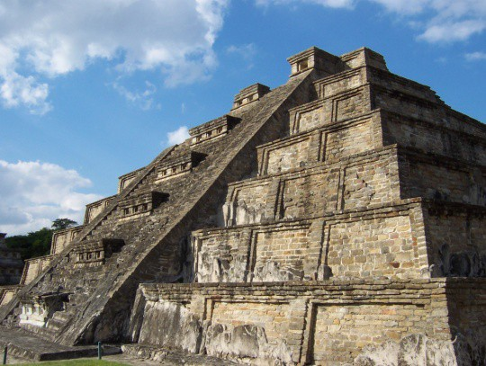

The future is in your hands.
Don’t wait until mañana!!!
Join our next information session for 2017 fall admissions:
THURSDAY, MARCH 30th
5:30 – 6:30 p.m.
Language Building 109
Refreshments provided

Why study with us at UNT?

Small classes, more one-on-one attention.
Seminars are conveniently held 5:00 – 7:50 pm, Mon.-Thurs.
Students are active partners in an education that is personalized, attentive, comprehensive and empowering.
We offer a wide variety of specializations, research interests and approaches to studying poetry, narrative, linguistics, film, & theater.
The faculty is culturally and ethnically diverse from: Cuba, South Africa, Spain, India/Thailand, Korea, Mexico, and the U.S.
Collectively, our faculty have hundreds of hours of experience. We are continuously active and productive scholars as specialists in our fields.
Because we are passionate about what we do and care about student success!

Students choose from one of the following tracks of study:
- Without thesis: 36 hours of Spanish graduate coursework credit, OR 30 hours of Spanish graduate coursework credit plus 6 hours of graduate coursework credit in a minor area. Total: 36 credit hours. Students must take and pass 3 area comprehensive exams in order to receive the M.A. in Spanish.
- With thesis: 30 hours of Spanish graduate coursework credit, plus 6 hours of thesis credit; OR 24 hours of graduate coursework credit in Spanish, plus 6 hours of graduate coursework credit in a minor area, plus 6 hours of thesis. Total: 36 credit hours. Students must maintain a 3.75 GPA throughout their graduate work. The thesis requires an oral defense in order to receive the M.A. in Spanish.
In addition to our regular course offerings, we teach 2 accelerated graduate seminars through the Spanish Summer Institute yearly, so students can graduate faster!

