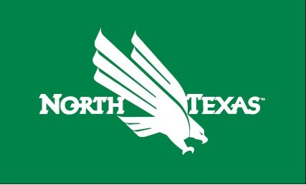
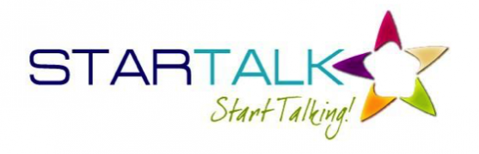

STARTALK and the University of North Texas at Denton Campus invite applicants for

STARTALK Program Welcome to My World (Russian and Chinese)
ДОБРО ПОЖАЛОВАТЬ В НАШ МИР! 欢迎来到我的世界!
FREE TO ALL STUDENTS
Program dates: June 4 - June 29, 2018

Program location: Language Building, UNT, Denton, Texas, 1155 Union Circle #311127, Denton, TX 76203
Applications may be submitted from February 15, 2018 to April 16, 2018. All successful applicants will be informed no later than April 30, 2018.
STARTALK Program at UNT is a non-residential, intensive (four weeks, 120 instructional hours) program that offers the choice of Russian or Chinese language courses at the Novice level and is fully funded by a federal grant.
All program activities, including tuition, textbooks and other learning materials are free of charge to students. Upon successful completion of the program, students will be given the opportunity to take a free UNT placement test and be awarded up to six college credit hours. The number of program participants is limited to 24 students for the Russian group and 24 students for the Chinese group and will be selected from a pool of applicants.
The selection criteria are based on academic performance and interest in pursuing Russian or Chinese after the completion of the program.
More information and application instructions can be found on http://worldlanguages.unt.edu
Contact Information: Please direct all inquiries concerning the program to Dr. Tatiana Filosofova, Program Director, at tatiana.filosofova@unt.edu

