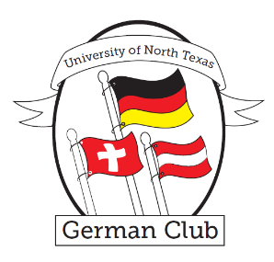University of North Texas

German Club

# 

# About the Club

The German Club is a student organization that helps immerse students in the German culture and language. Each semester we provide opportunities for students to meet and mingle with their peers and the German faculty and practice their German.

See OrgSync for more info about the club and details on upcoming events.

# 

# Upcoming Events

**Stammtisch**

February 23 – 6:30 pm (@Metzler’s

628 Londonderry Lane, Denton)

April 6 – 6:30 pm (@Metzler’s

628 Londonderry Lane, Denton)

**Movie Night**

March 2 – 6:30 pm in Lang 107A (Murnau’s *Nosferatu*)

**International Food Bash**

March 30 – 3 pm (4th Floor of Language Building)

**Soccer Game & Grillfest**

April 20 – 4:30 pm (@South Lakes Park

556 Hobson Lane, Denton)

**Weihnachtsstammtisch**

December 1 – 6 pm (Abbey Inn in Denton)

Contact Timothy Walker, the German Club president, for questions.

Email: timothywalker@my.unt.edu