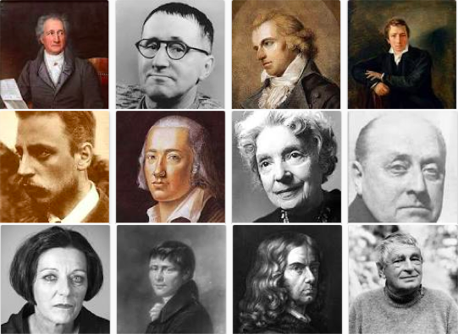  Klub der Toten & Lebenden Dichter  Aktivitäten:  Read, write, and share poetry in German with the moderation of faculty. Facilitate the submission of poetry to German, Swiss, and Austrian poetry magazines, journals, and websites.  Meetings Lang 402 @ 11:00 am:  OCTOBER 2  OCTOBER 16  OCTOBER 30  NOVEMBER 6  NOVEMBER 27 | Germanpoetryclub@myunt.onmicrosoft.com  Germanpoetryclub@myunt.onmicrosoft.com  Germanpoetryclub@myunt.onmicrosoft.com  Germanpoetryclub@myunt.onmicrosoft.com  Germanpoetryclub@myunt.onmicrosoft.com  Germanpoetryclub@myunt.onmicrosoft.com  Germanpoetryclub@myunt.onmicrosoft.com  Germanpoetryclub@myunt.onmicrosoft.com  Germanpoetryclub@myunt.onmicrosoft.com  Germanpoetryclub@myunt.onmicrosoft.com  Germanpoetryclub@myunt.onmicrosoft.com  Germanpoetryclub@myunt.onmicrosoft.com  Germanpoetryclub@myunt.onmicrosoft.com  Germanpoetryclub@myunt.onmicrosoft.com

